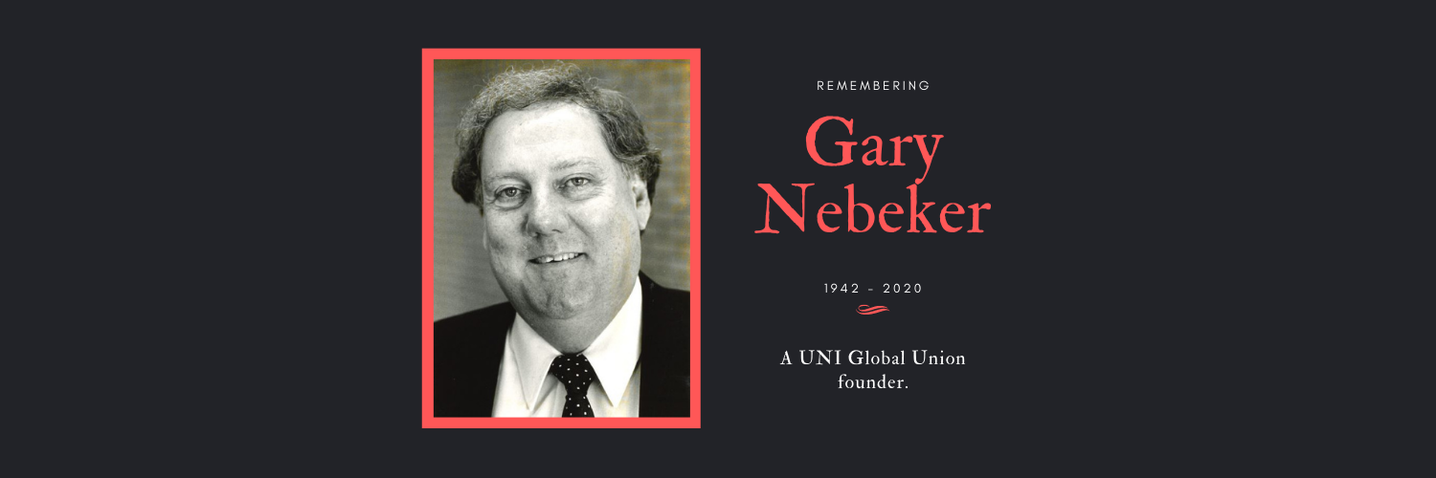By Philip Jennings, former UNI Global Union General Secretary

During the opening session of the recent UNI Americas Regional Conference, tributes were made to those union members who had passed away during the four-year conference period. One of those heroes was Gary Nebeker who was lost to us following a short illness, just before the conference.

Gary was born in Berkeley, California, in September 1942 and was one of the key builders of the new global union. I had a friendship with him that spanned thirty years.

When I first met him in 1980 I had just joined the staff of FIET, one of the founding partners of UNI Global Union. Gary had a California look, sneakers, jeans, union t-shirt and windcheater and a very relaxed and welcoming air.

His international union responsibilities meant that Gary travelled the world and wherever he went he carried the easiness of California with him in his dealings with people. He loved USA sport and had a loyalty to the Los Angeles Dodgers baseball team and an encyclopedic knowledge of teams, players and tactics.

With Gary, I was introduced to the ‘ground up’ realities of union life in the USA. Hair raising stories of tough organizing campaigns, threats of physical violence, arduous picket line duty, organizing strikes. From Gary, I learned that organizers were banned from entering premises, enforced no go zones around premises, intimidation of staff from closed anti-union sessions, to one-on-one ‘this won’t be good for your career` meetings, to victimization and dismissal of those employees taking a stand for unions. It was a world apart. Reagan and Thatcher were in their tarnished ‘neo liberal’ pomp and the ground level union busting quickly transformed into a global effort to deny freedom of association, the repercussions of which we still suffer from today.

Gary was a local and international union organizer for the Retail Clerks Union (RCIU), rising to the position of International Vice President of the UFCW. The UFCW was founded in June 1979 as a result of the merger of the RCIU and the Amalgamated Meatpackers and Butchers union (AMC). The RCIU affiliated to Fiet in 1954, the first union from the USA to join, and have played an active role in the International ever since.

Gary’s global union work began when he was appointed the Assistant Director of the RCIU international affairs department in the late 1970s, rising to the Director position of the UFCW in 1984.

His approach was to learn of local union realities by visiting with unions directly. In his early years he travelled extensively to Asia, Africa, the Americas and Europe. Partnerships were established with the commerce unions in Japan. In the Americas, in Brazil close working relations were established with Lula as he began his ascendancy to political office.

Gary built strong bonds with people and they knew that they could rely on him for advice and solidarity. He was a trusted friend and skillfully developed authentic and independent international relations with unions at a time of significant geopolitical tensions.

He accompanied Tom Whaley, Executive Vice President of the 1.3 million strong UFCW, to meetings of the FIET executive and management committee and played a key decision-making role in the life of FIET from the late 1970s on. Tom Whaley was FIET President from 1983-87.

Gary played a key role in the Commerce trade section of FIET. His no nonsense stories of union busting by retailers in the USA, his warnings that ‘this can happen to you’, his support for a comprehensive FIET strategy to deal with multinationals did not fall on deaf ears.
He drew attention to the anti-worker policies of Walmart, which had begun its own globalization path, a path he said that other mega retailers would be sure to follow and which he insisted required a strategic union response. He found eager supporters and the work of Commerce was transformed through a series of influential FIET commerce union summits hosted by the UFCW in Washington DC. His legacy continues as Stuart Appelbaum, Executive Vice President of the UFCW and President of the RWDSU, is President of UNI Commerce Global Union today and Stan Gacek who was Gary’s deputy for several years is the UFCW Senior Adviser for Global Strategies. Joe Hansen UFCW President from 2004-2014 was the President of Uni Global Union from 2003 to 2010 and was often to call on Gary’s global expertise.

In 1989 when Heribert Maier, the FIET General Secretary, left the organization to become the Deputy Director General of the ILO, Gary was a member of the FIET Executive that appointed me as acting General Secretary at the Buenos Aires Executive. 1989 was a momentous year; within months the Berlin Wall had fallen, and world history was on a new trajectory. Gary had followed the struggle of Solidarność closely and encouraged FIET to be active in Central and Eastern Europe. FIET made an extraordinary effort to build links and membership in CEE. The economic shock therapy brought new private investment and a significant presence of multinationals in commerce there.

The UFCW was the host of the 1991 FIET Congress in San Francisco. Gary and I spent many hours together working on the fine details, our plans not upended by an earthquake which damaged the Congress hotel.

On the eve of the Congress, the attempted Soviet Union coup d’etat took place in Moscow. With numerous unions present at the Congress from Central and Eastern Europe it was a moment to protest this coup attempt.

Our Congress opening ceremony, which was rocked by the Ed Hawkins singers’ rendition of ‘Oh Happy Day’ energized the thousands that took to the streets which was originally planned as a protest at the treatment of janitors at Apple Computers was also quickly changed into a demo against the coup in Moscow. The march was joined by thousands and concluded with a noisy rally in San Francisco’s Union square. I remember wondering with Gary how could we succeed in getting media coverage for the Congress. It was a pleasant surprise to be told that CNN had given our demonstration global news coverage as messages poured in from all corners of the world with the then magic words `We saw you on CNN`.

Gary was elected as FIET First Vice President at the San Francisco Congress. He was elected FIET President at the 1995 Congress in Vienna. The next five years were to prove some of the most momentous in the 90-year history of FIET.

He was a supporter of the decision to build a new and combined headquarters for FIET and the then Post and Telecoms International Union (PTTI) in Nyon. He played a key role in the decision of the FIET, Communications International (former PTTI), the International Graphical Workers Federation (IGF) and Media and Entertainment International (MEI) to create a new International.

He played a hands-on role in the negotiations to build what was to become Union Network International. He had strong views as to the new organization’s goals and its organizational principles. The new international should be global, regional and sectoral. His friendly unfussy manner contributed to a positive atmosphere in the sometimes demanding talks on rules, finances, people, and strategic plans. He played oversight role during the construction of the new office in Nyon. He turned the earth to begin construction and was there for its inauguration.

He had strong views that in a world dominated by global business and supply chains, the new UNI required a strong global union response that must include a strong organizing dimension. He insisted that the new international must not enter a cul-de-sac of dealing just with the internal organizational matters but must be aggressive and outward looking from day one. That was his message when UNI launched its work with a 24 hour worldwide series of video conferences.

Gary chaired the Cardiff, Wales FIET executive in 1998 that endorsed the plans and laid down the conditions for the new International. He presided over the historic FIET World Congress in Sydney, Australia in March 1999 which was to be the last such FIEt World Congress. He stood down as FIET President at the conclusion of the Congress he remained a member UNI executive to usher in a new era for the new International.

These are just some of the most important snapshots of the outstanding contribution made by Gary to both FIET and UNI Global Union.

Gary never wanted any fuss to be made of him, he was always down to earth, there was no grandstanding from him and he understood the meaning of loyalty to a cause, to an organization and to working people.

In his book The Dubliners, James Joyce writes `The light music of whiskey falling into a glass – an agreeable interlude’. I had many such pleasant interludes with Gary. We raise this final glass to him and recognize he will always have a special place in the history of FIET and the life of UNI Global Union. We express our thanks to him for his work, his friendship and commitment.

We send our condolences to Sue, his loving wife of 37 years.

